1. Are DHCP messages sent over UDP or TCP?

**Ans: UDP.**

1. Draw a timing datagram illustrating the sequence of the first four-packet Discover/Offer/Request/ACK DHCP exchange between the client and server. For each packet, indicated the source and destination port numbers. Are the port numbers the same as in the example given in this lab assignment?

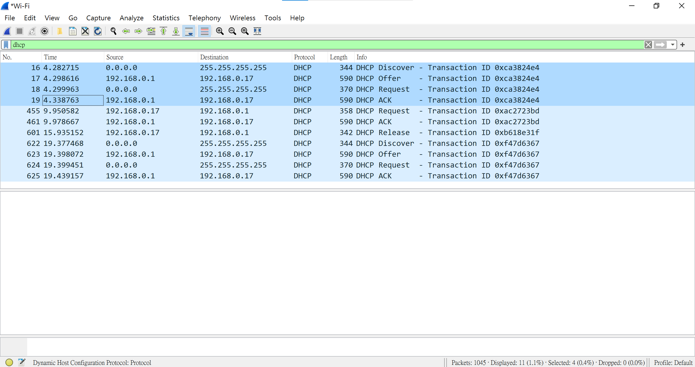

**Ans:**

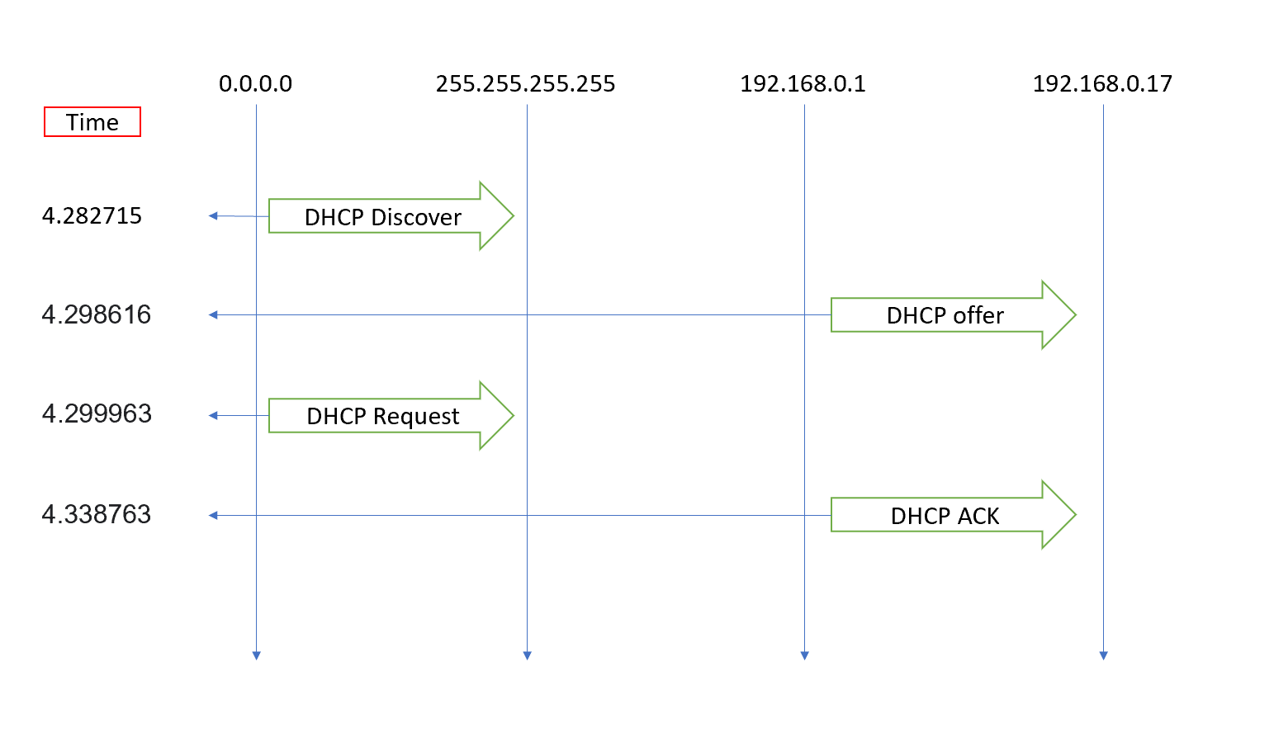

1. What is the link-layer (e.g., Ethernet) address of your host?

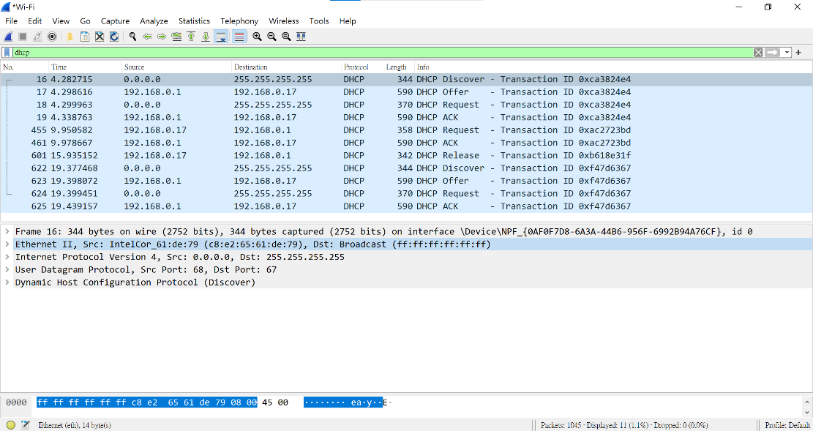

**Ans : Source : c8:e2:65:61:de:79.**

1. What values in the DHCP discover message differentiate this message from the DHCP request message?

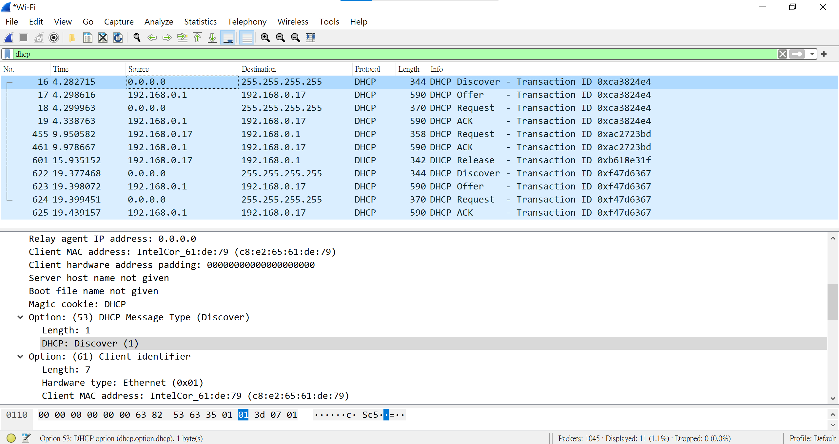

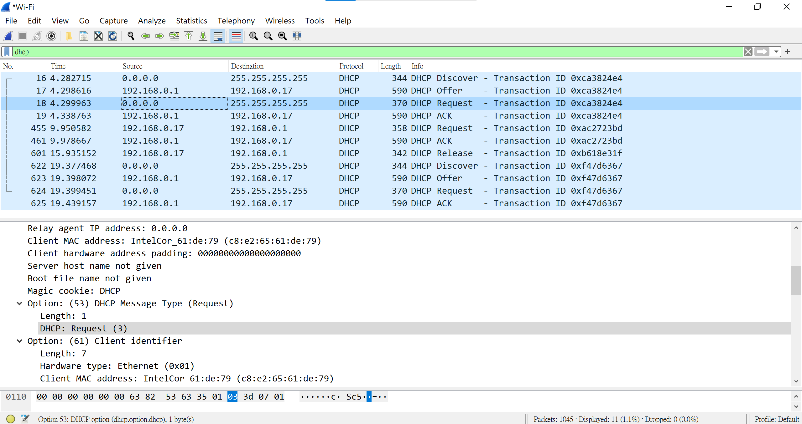

**Ans : DHCP Message Type.**

1. What is the value of the Transaction-ID in each of the first four (Discover/Offer/Request/ACK) DHCP messages? What are the values of the Transaction-ID in the second set (Request/ACK) set of DHCP messages? What is the purpose of the Transaction-ID field?

**Ans :**

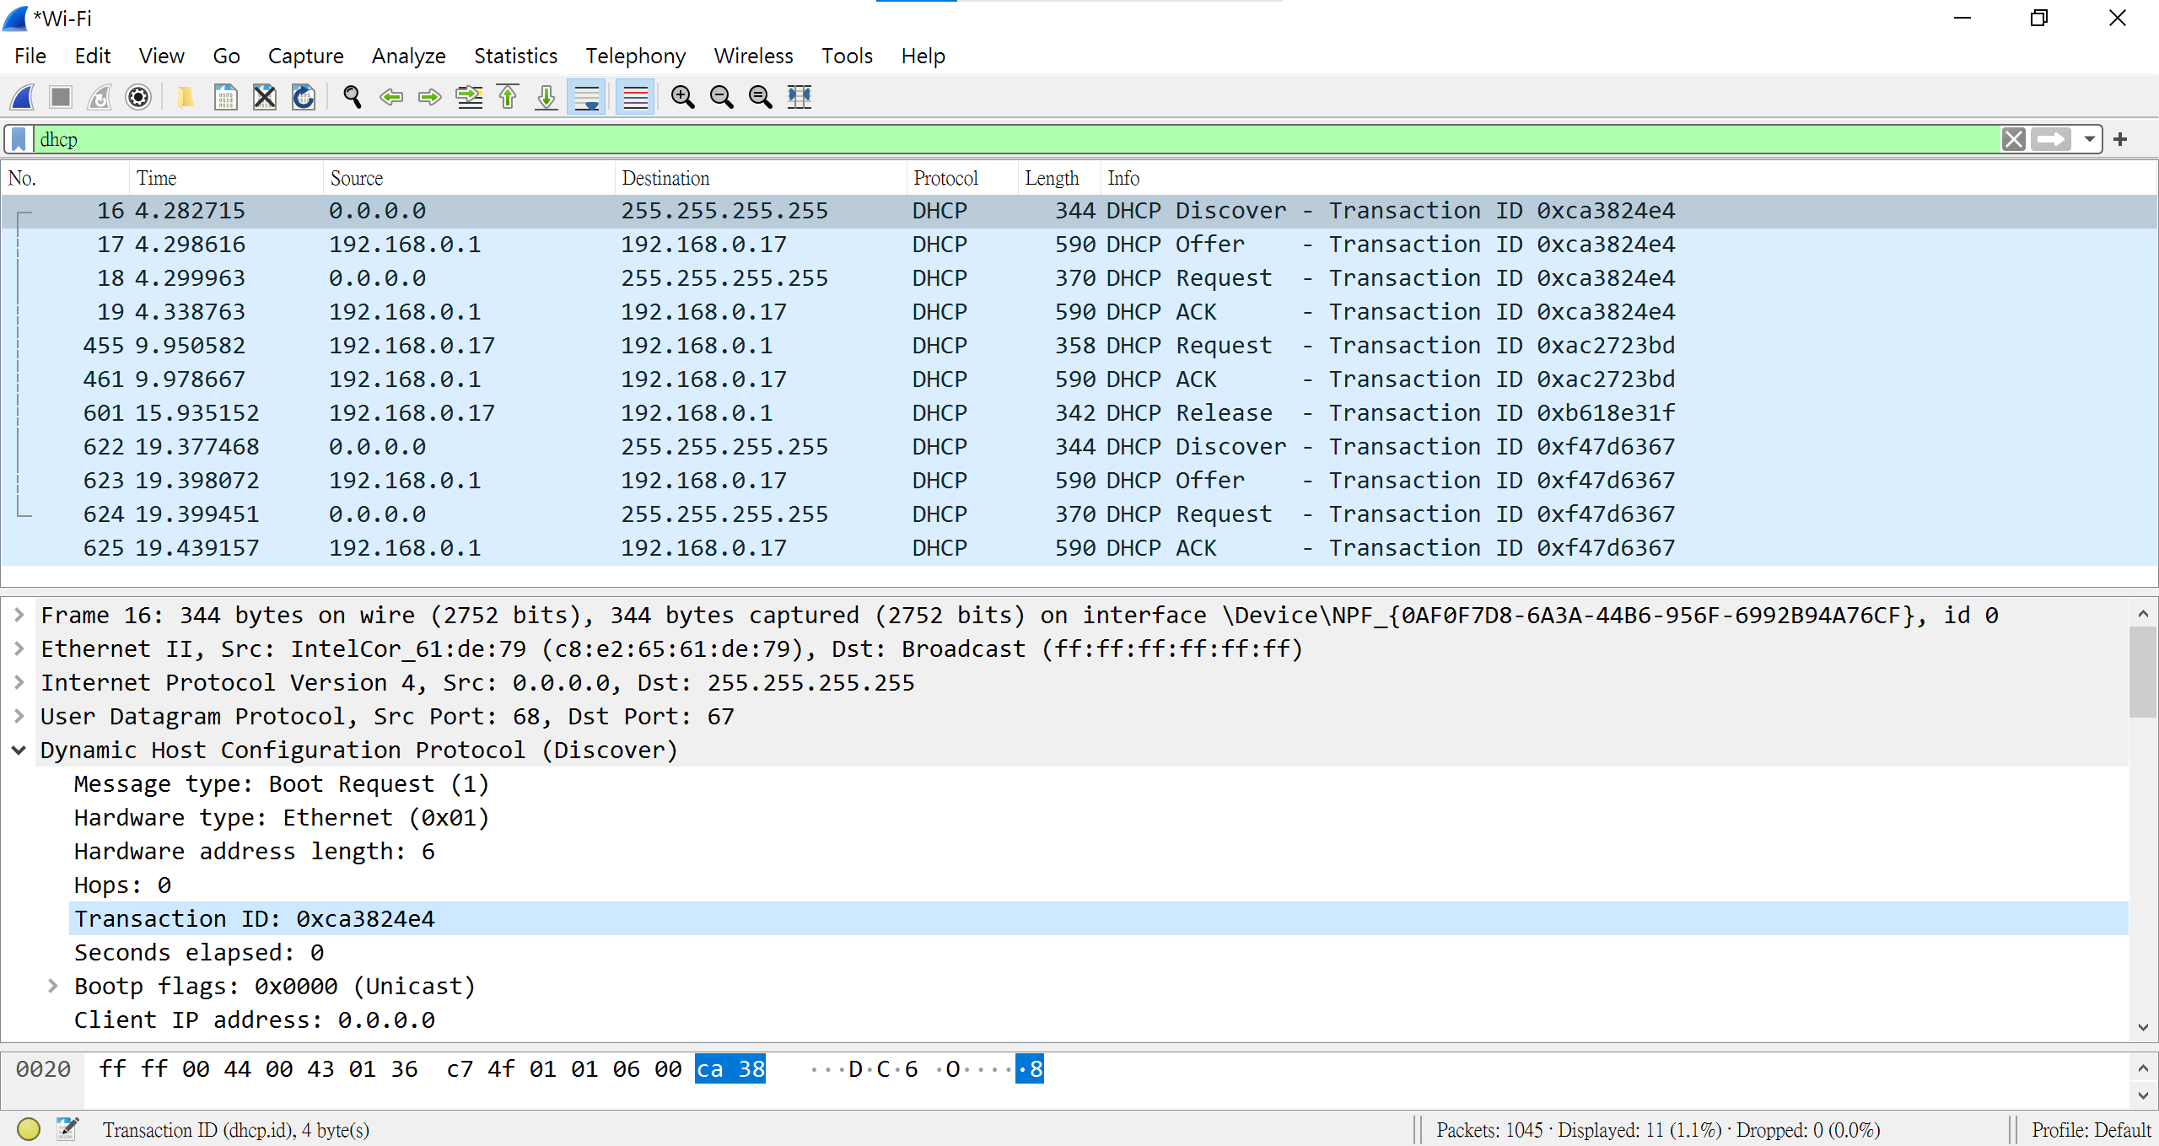

1. **4個(Discover/Offer/Request/ACK) Transaction ID 皆是 0xca3824e4.**

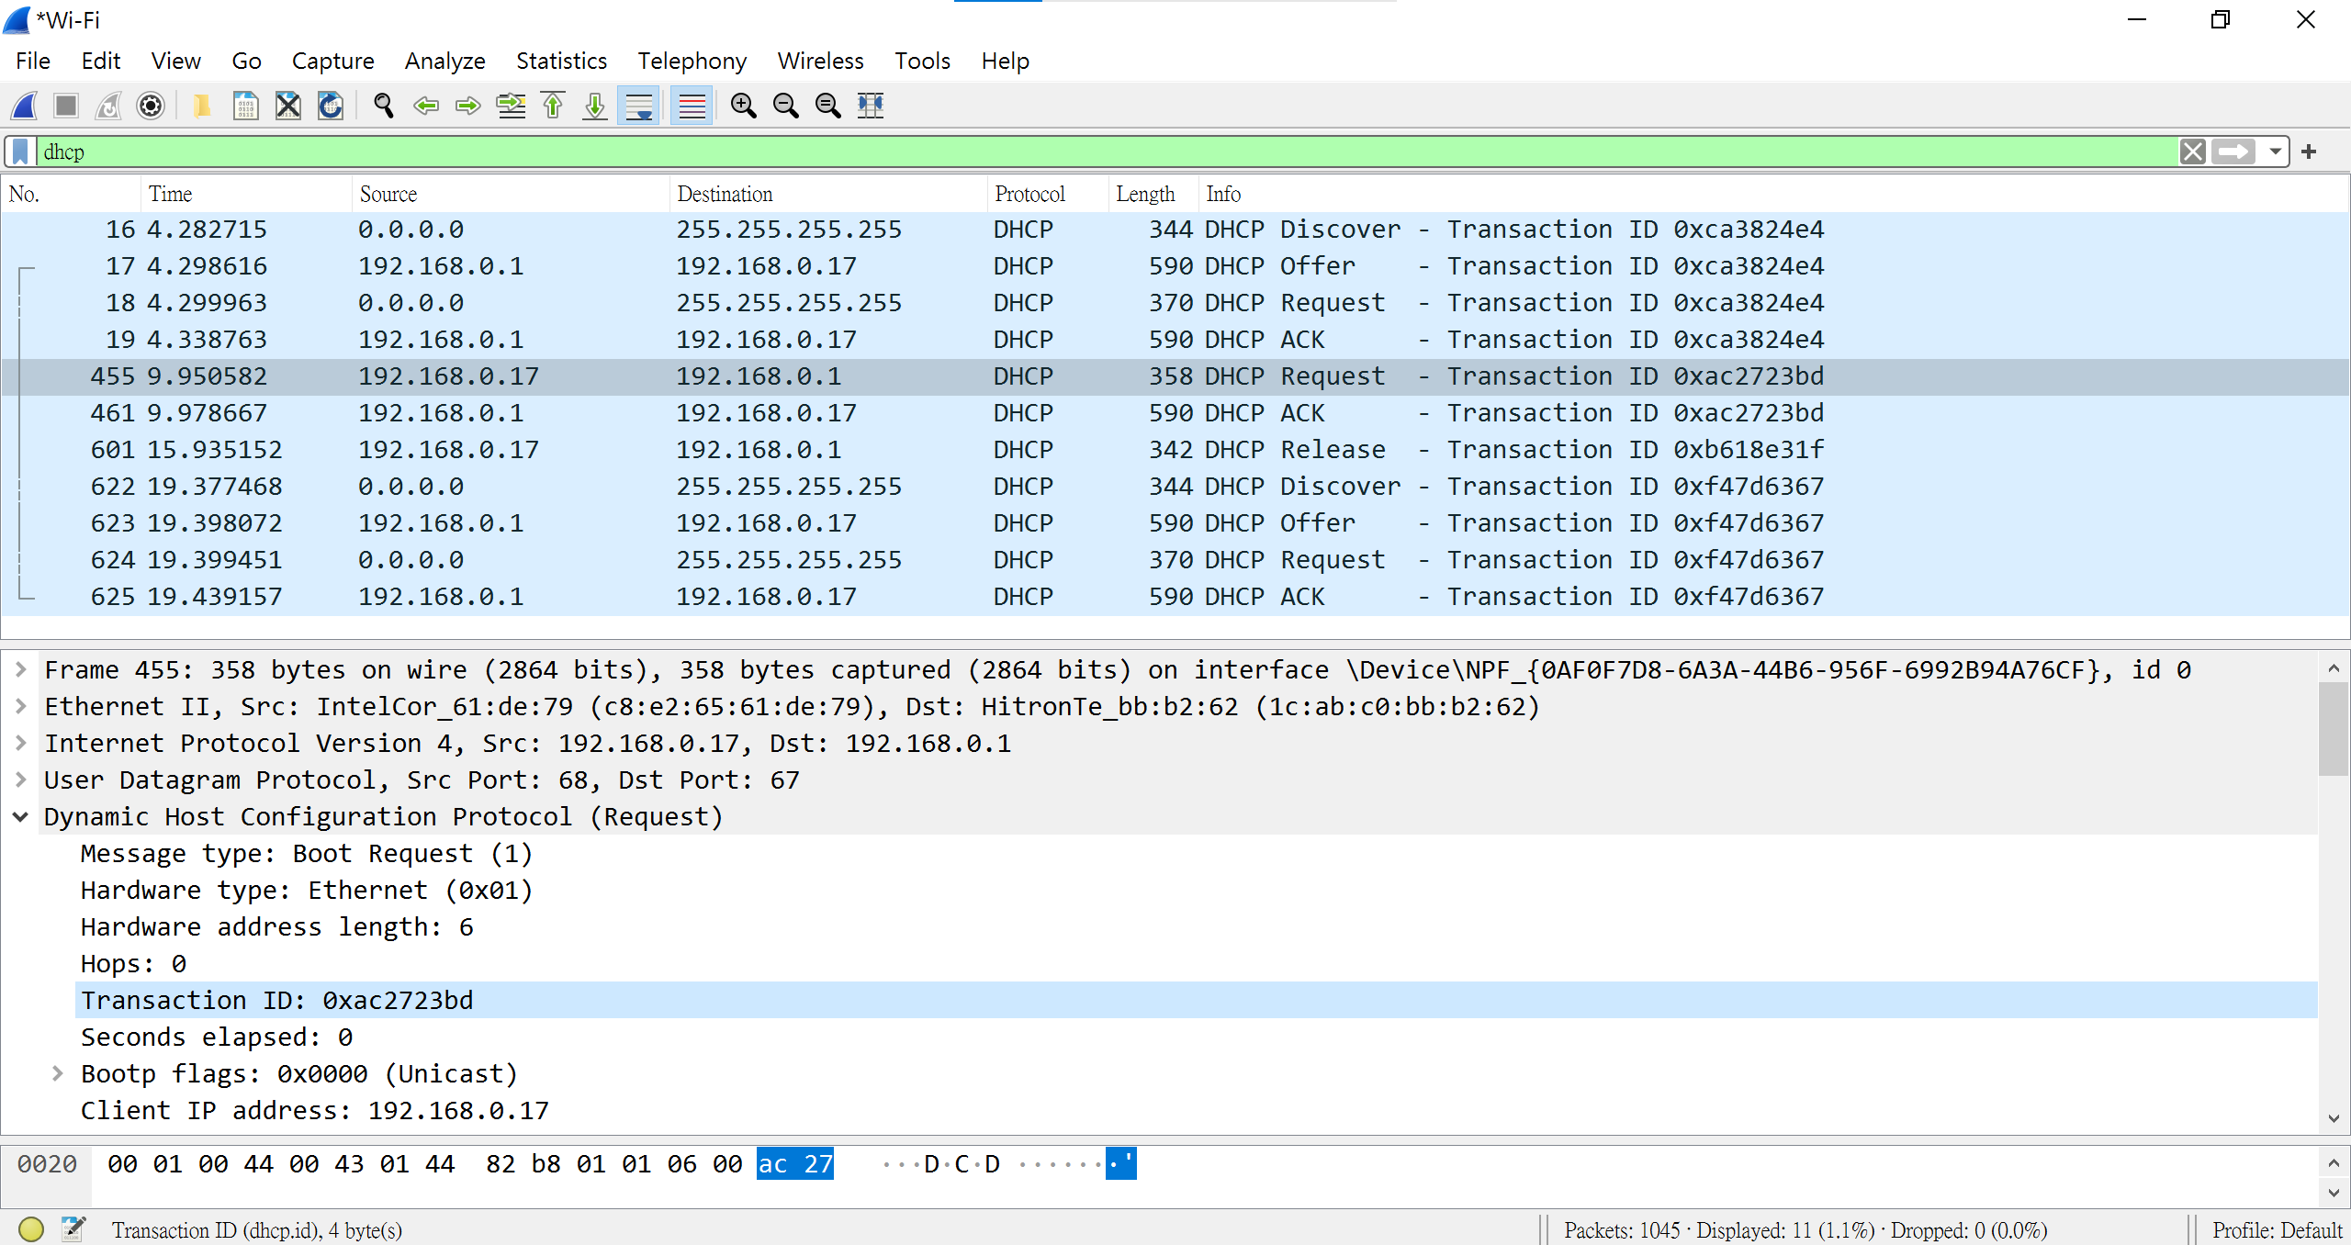

1. **2個(Request/ACK) Transaction ID 皆是 0xac2723bd.**

**(3.)當DNS服務器返回dns消息時，使用的“Transaction ID”必須與發送請求時使用的“Transaction ID”相同，簡單來說我們必須在同一個聊天室才能看到彼此的訊息，Transaction ID就是聊天室編號。**

1. A host uses DHCP to obtain an IP address, among other things. But a host’s IP address is not confirmed until the end of the four-message exchange! If the IP address is not set until the end of the four-message exchange, then what values are used in the IP datagrams in the four-message exchange? For each of the four DHCP messages (Discover/Offer/Request/ACK DHCP), indicate the source and destination IP addresses that are carried in the encapsulating IP datagram.



**Ans :**

**Discover IP address   =  255.255.255.255.  
Offer IP address          =  192.168.0.17.  
Request IP address    =  255.255.255.255.  
ACK IP address           =  192.168.0.17.**

1. What is the IP address of your DHCP server?

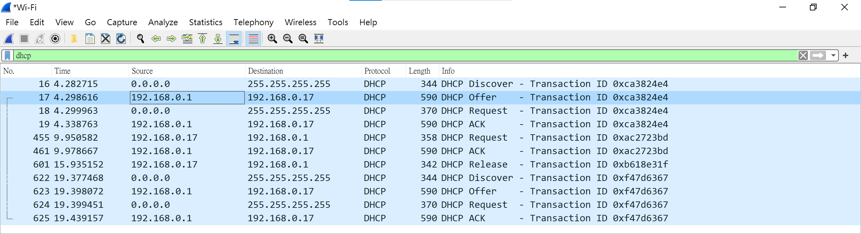

Ans : **IP address of my DHCP server is 192.168.0.1 .**

1. What IP address is the DHCP server offering to your host in the DHCP Offer message? Indicate which DHCP message contains the offered DHCP address.

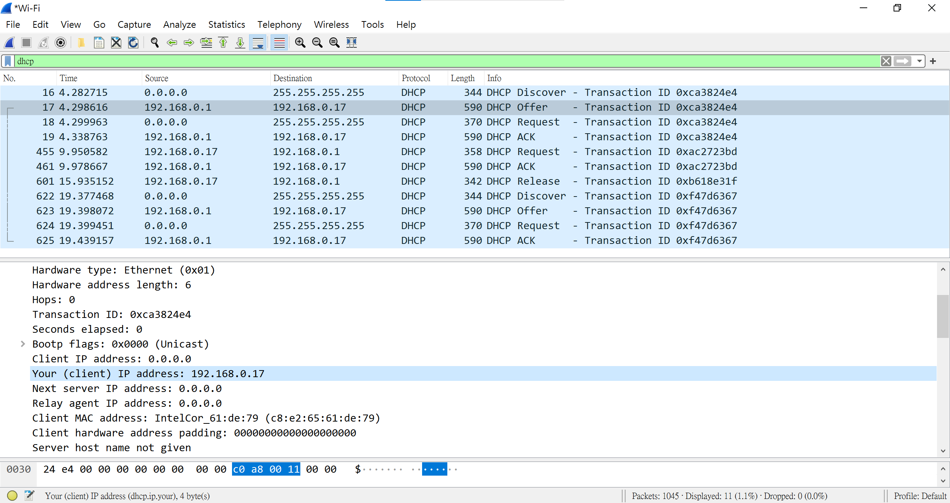

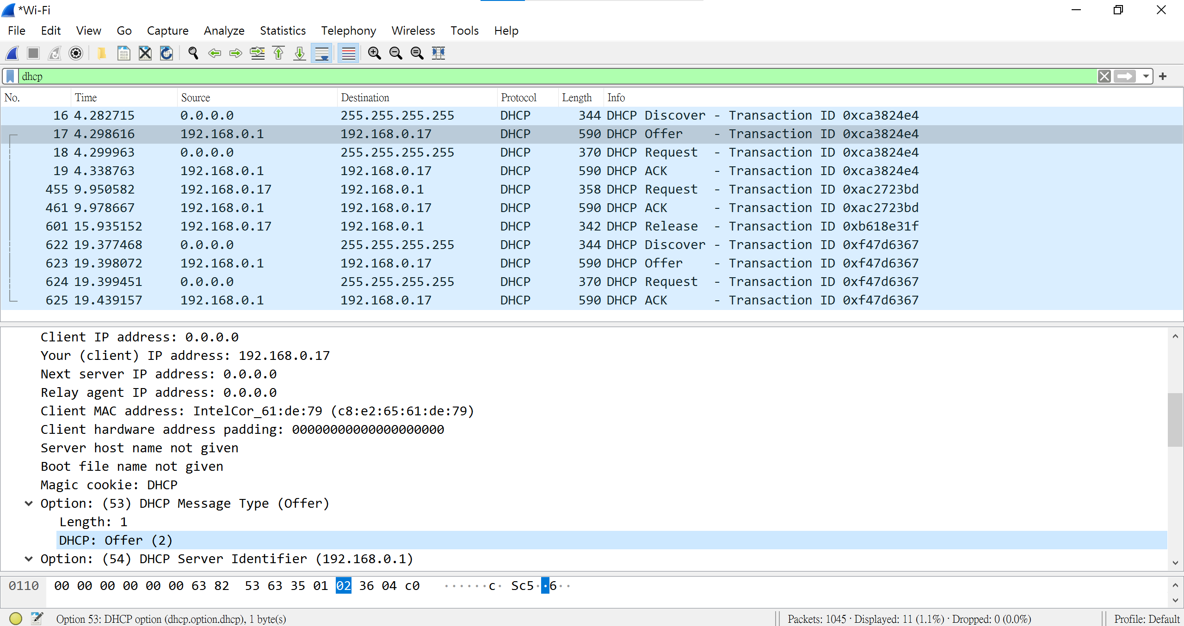

**Ans :**

1. **192.168.0.17.**
2. **DHCP: offer (2).**
3. In the example screenshot in this assignment, there is no relay agent between the host and the DHCP server. What values in the trace indicate the absence of a relay agent? Is there a relay agent in your experiment? If so what is the IP address of the agent?

**Ans :**

**接受packet時會經由agent再傳到host端，而agent即指router.**

1. **All of value have relay agent.**
2. **Yes.**
3. **IP: 192.168.0.1.**
4. Explain the purpose of the router and subnet mask lines in the DHCP offer message.

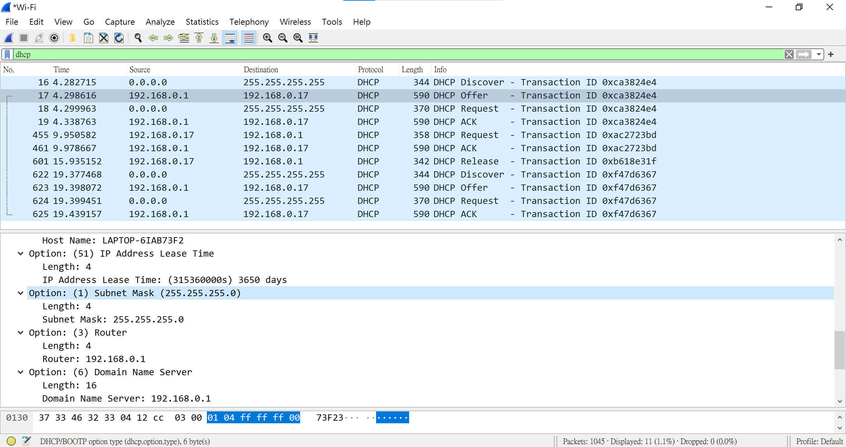

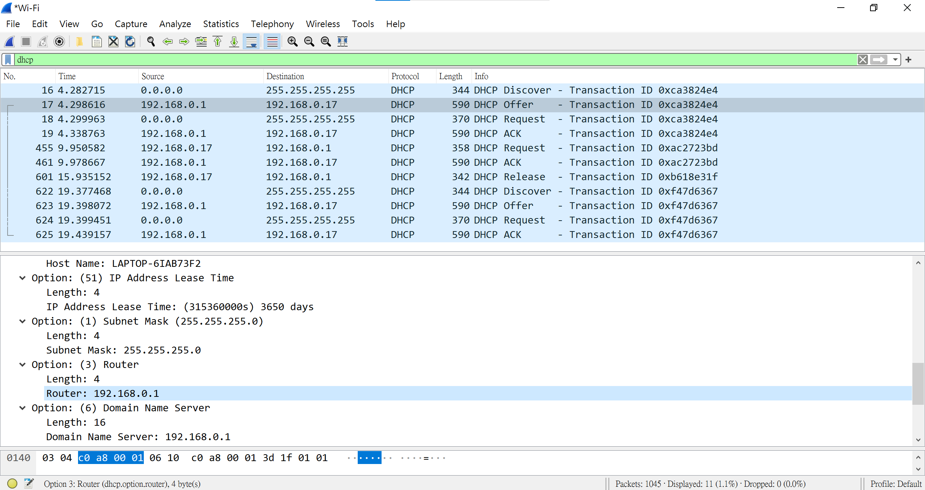

**Ans :** **Subnet mask lines 告訴 client 應使用哪個 subnet mask ( a,b,c…type ), (subnet mask & IP address ) 可獲得 default gateway。**

1. In the DHCP trace file noted in footnote 2, the DHCP server offers a specific IP address to the client (see also question 8. above). In the client’s response to the first server OFFER message, does the client accept this IP address? Where in the client’s RESPONSE is the client’s requested address?

**Ans :**

1. **Client doesn’t accept this IP address.**
2. **Not response.**
3. Explain the purpose of the lease time. How long is the lease time in your experiment?

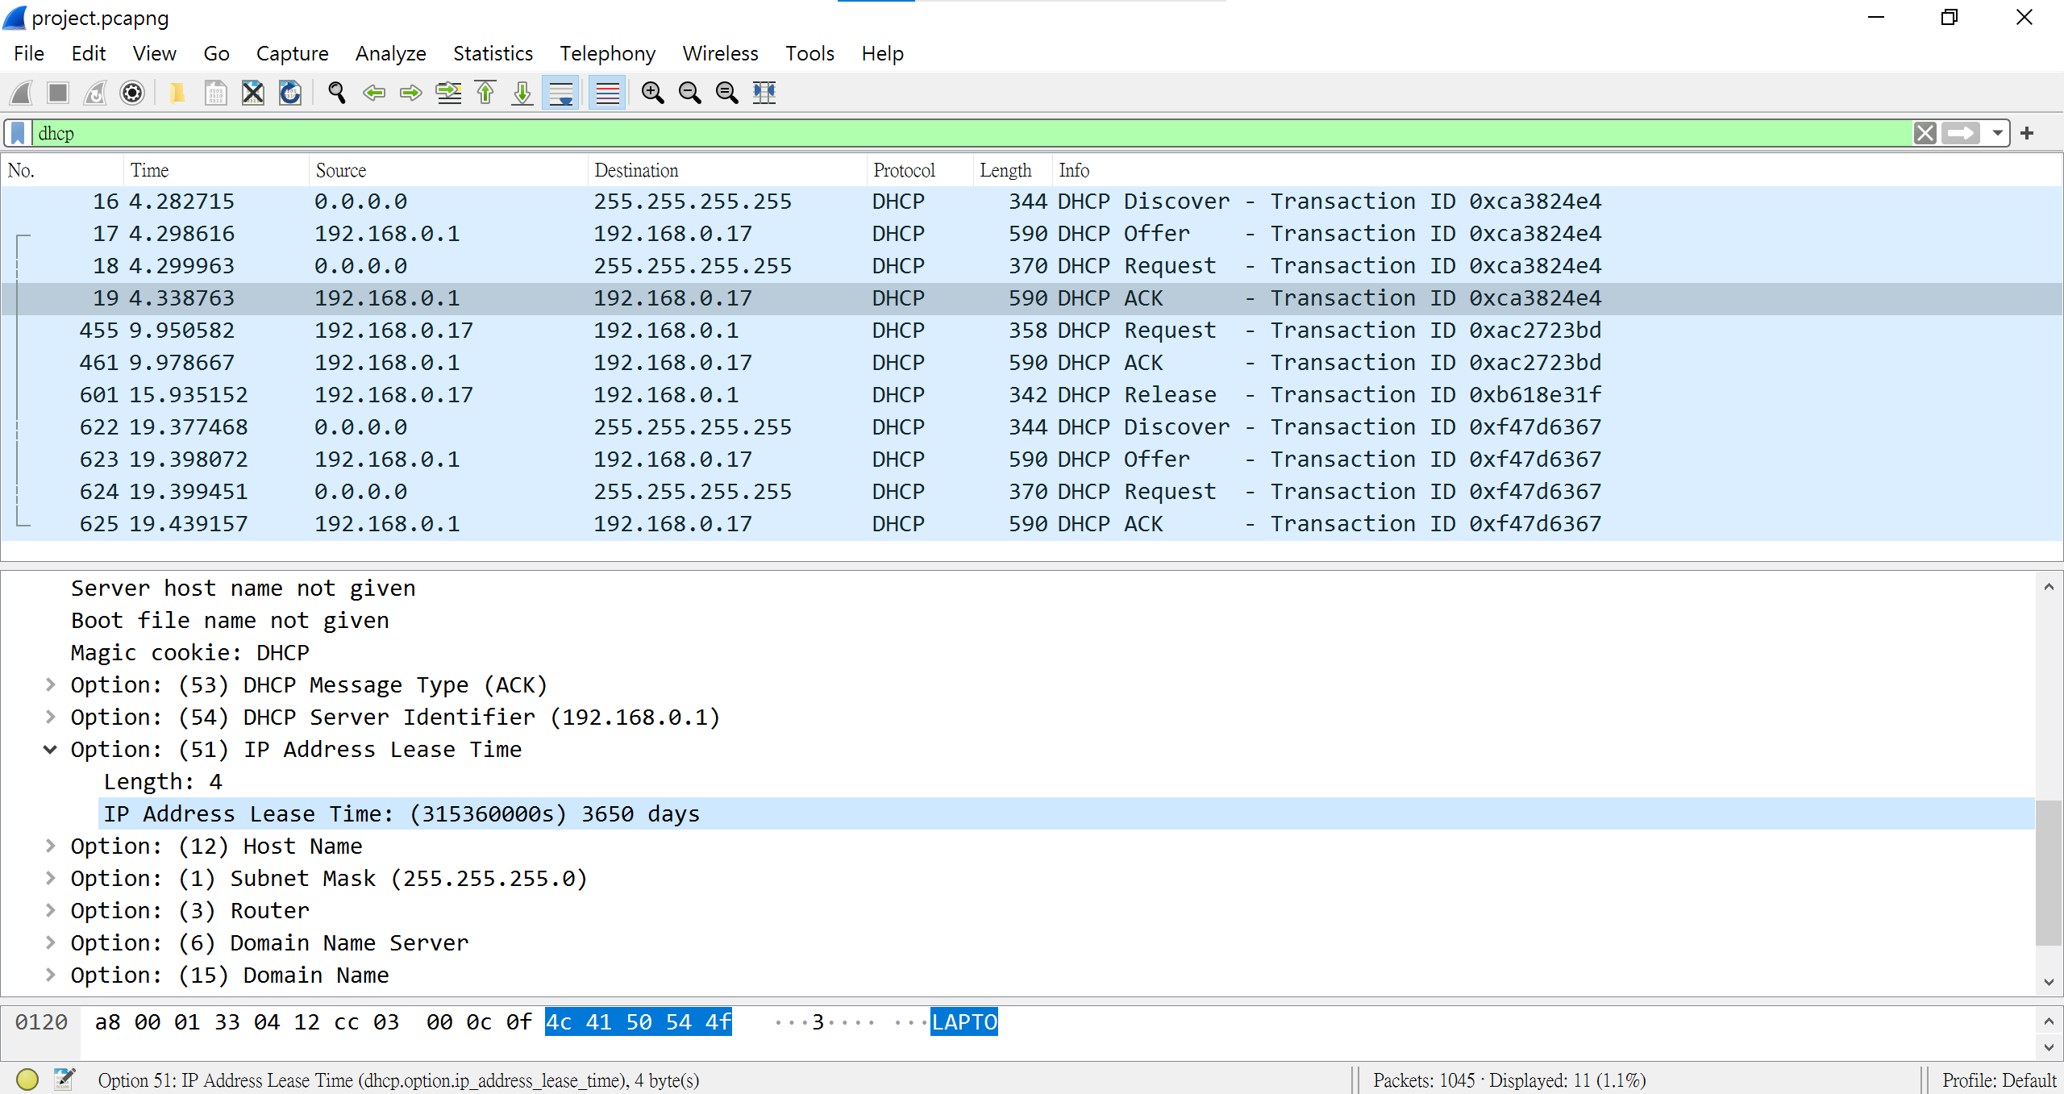

**Ans :**

**Lease time 是 DHCP server 指定一個 IP adress 給 client 所使用的時間，在此期間此 IP address 不會給其他 client 使用，當 lease time 到期或 client 自己 release，DHCP server 便可將此 IP address 賦予其他 client，而使用此獲取的 IP address 也被稱浮動 IP。**

**本次實驗 Lease time 為 : (315360000s) 3650 days。**

1. What is the purpose of the DHCP release message? Does the DHCP server issue an acknowledgment of receipt of the client’s DHCP request? What would happen if the client’s DHCP release message is lost?

**Ans :**

1. **由 DHCP server 送出 DHCP release 為取消其分配的 IP address上的租約的Message。**
2. **DHCP server 不會回傳 DHCP release message 給 client.**
3. **若 Message 丟失，client 將釋放 IP address，但是 DHCP server 將不會重新分配該 address，直到 client 在該 IP address 上的 lease time 到期為止。**
4. Clear the bootp filter from your Wireshark window. Were any ARP packets sent or received during the DHCP packet-exchange period? If so, explain the purpose of those ARP packets.

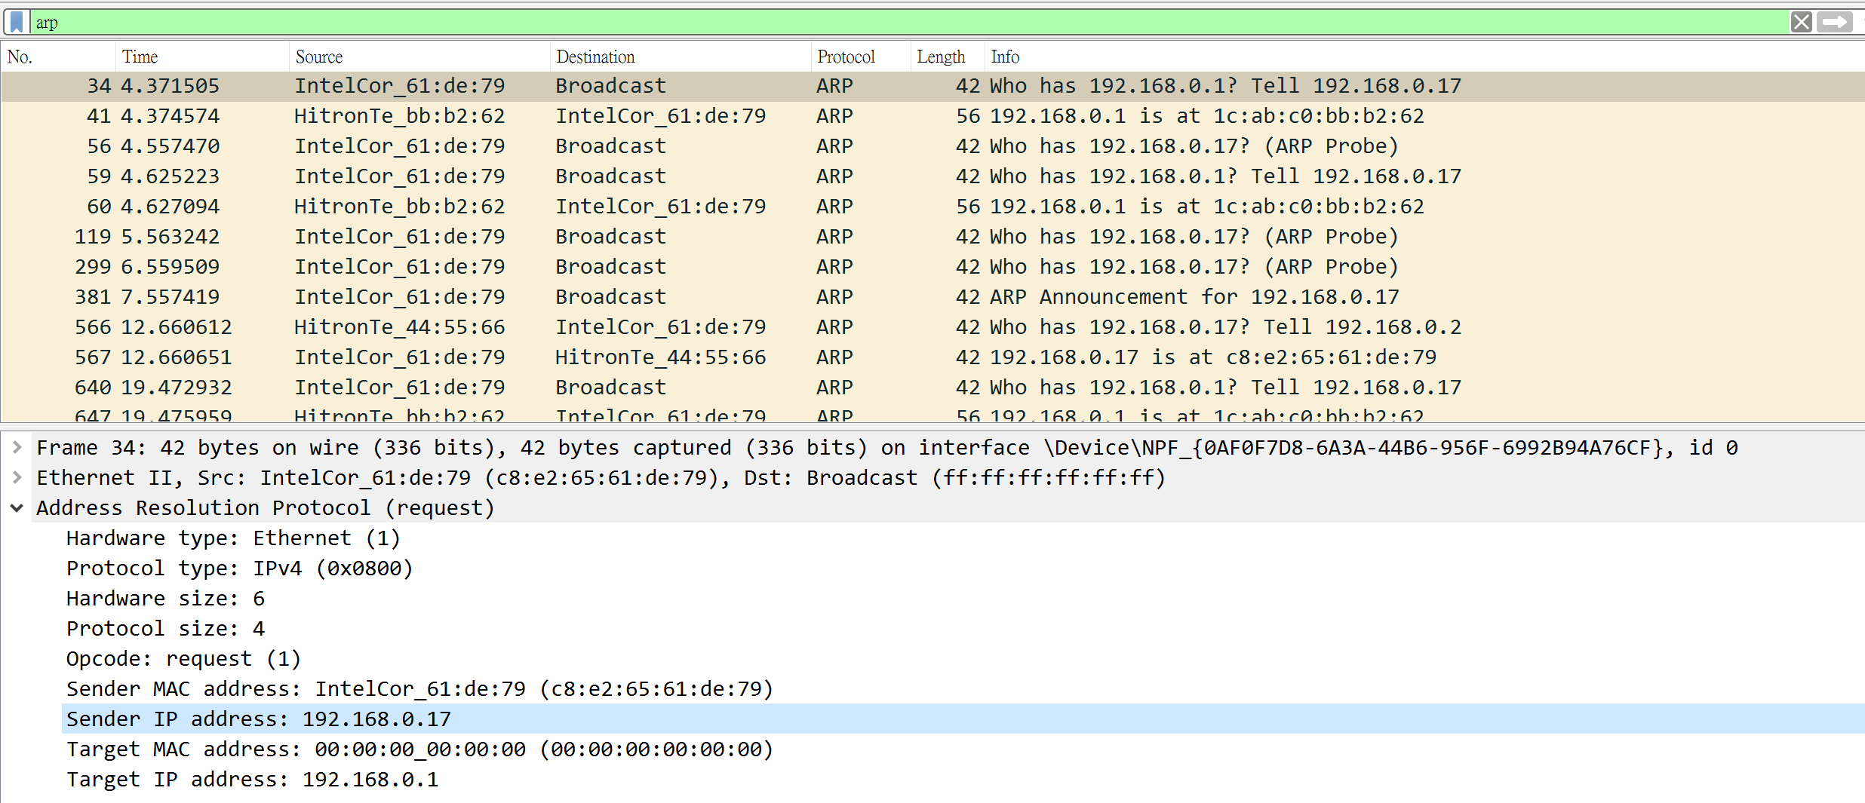

**Ans :**

**Yes, DHCP server 有給 ARP requests，且在給 client of IP address 之前，會先發布 ARP request ( broadcasts ) 以建立 client network 已知的 IP address。**